**Performance test of web servlet: by Apache JMeter**

**Test Results for amazon service:**

50 number of Users(Thread):

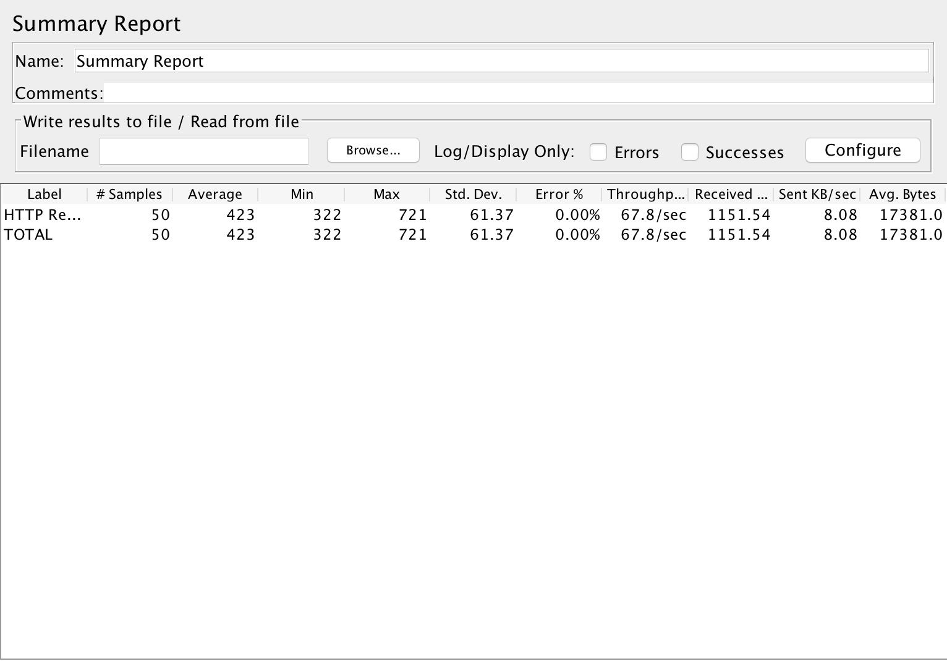

100 number of Users(Thread):

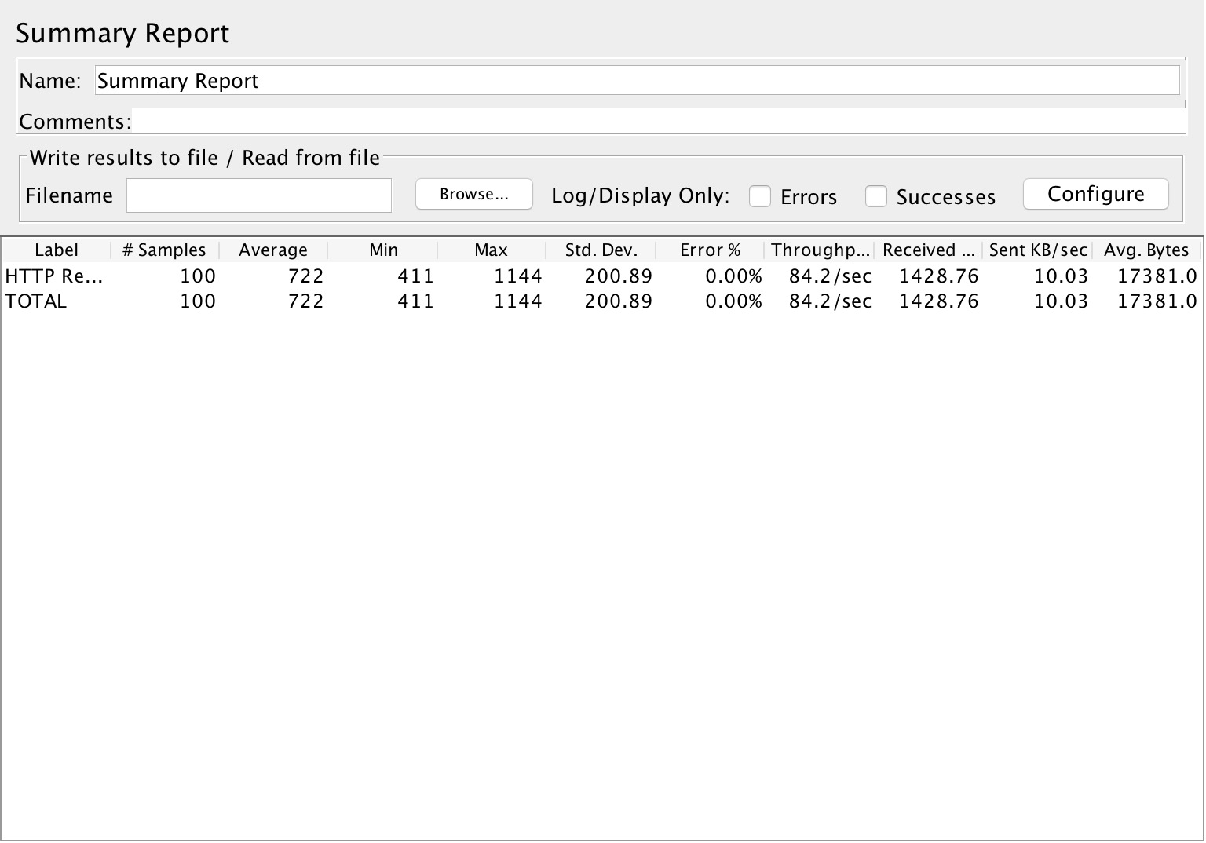

200 numbers of Users(Thread):

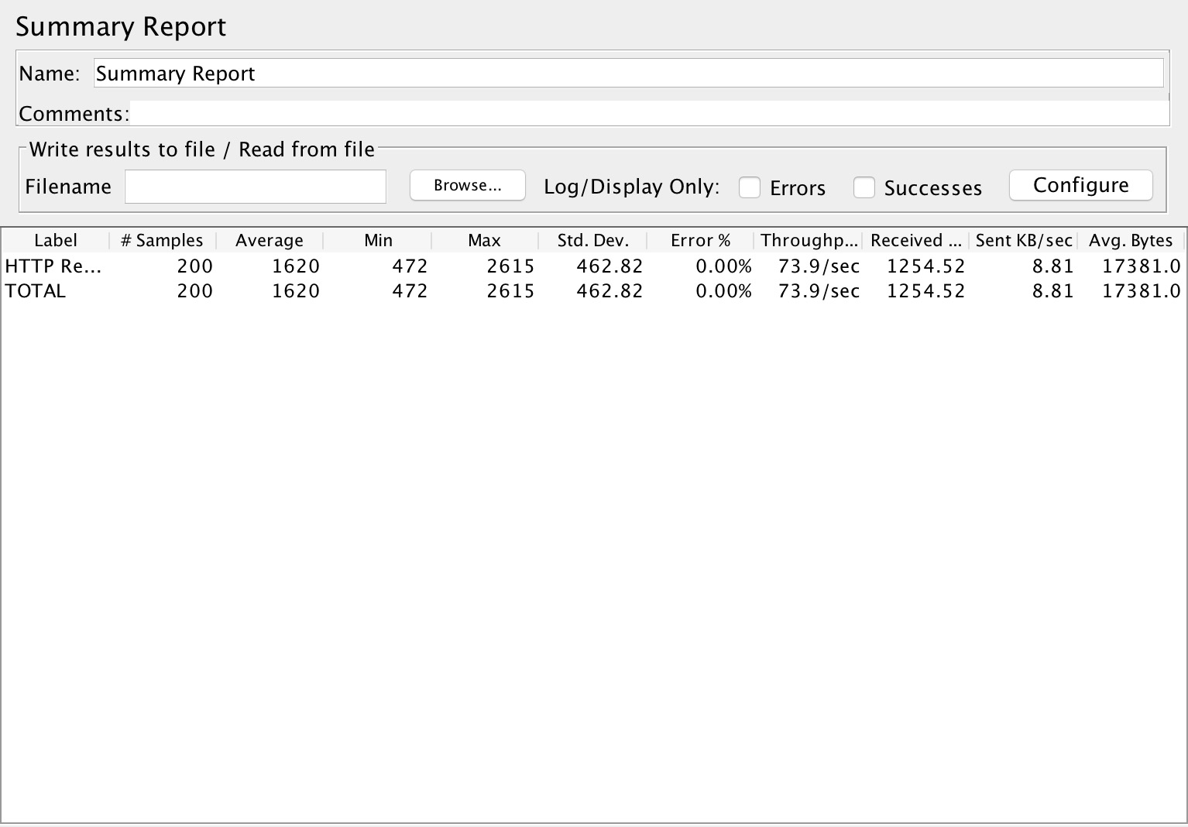

300 numbers of Users(Thread):

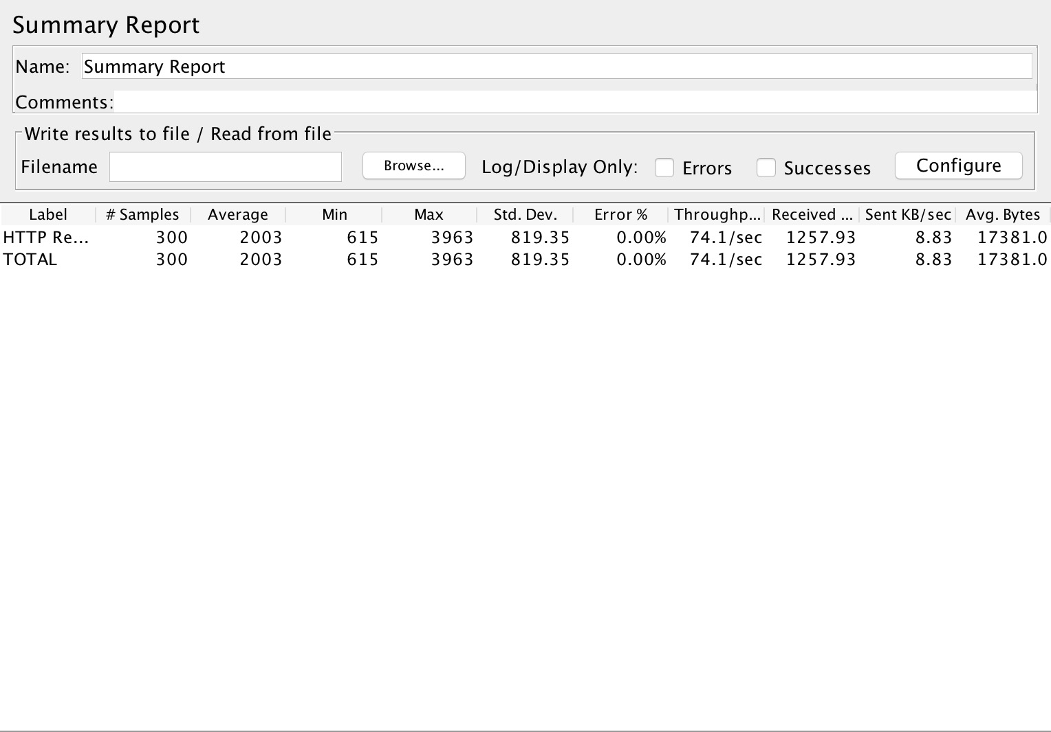

500 numbers of Users(Thread):

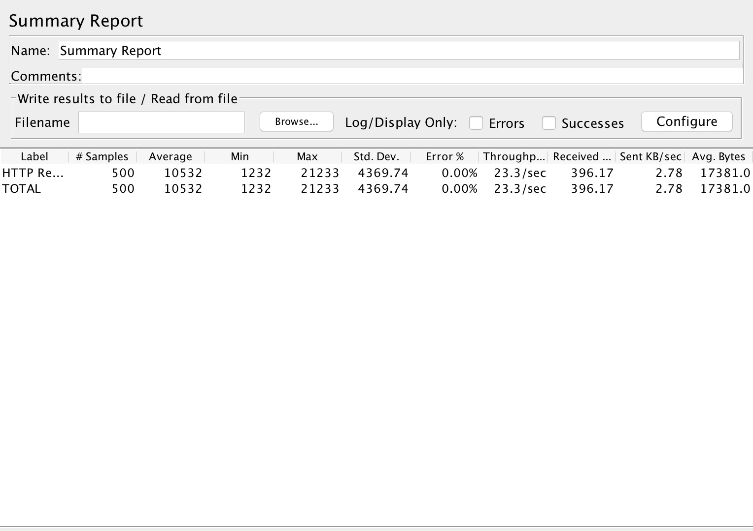

1000 numbers of Users(Thread):

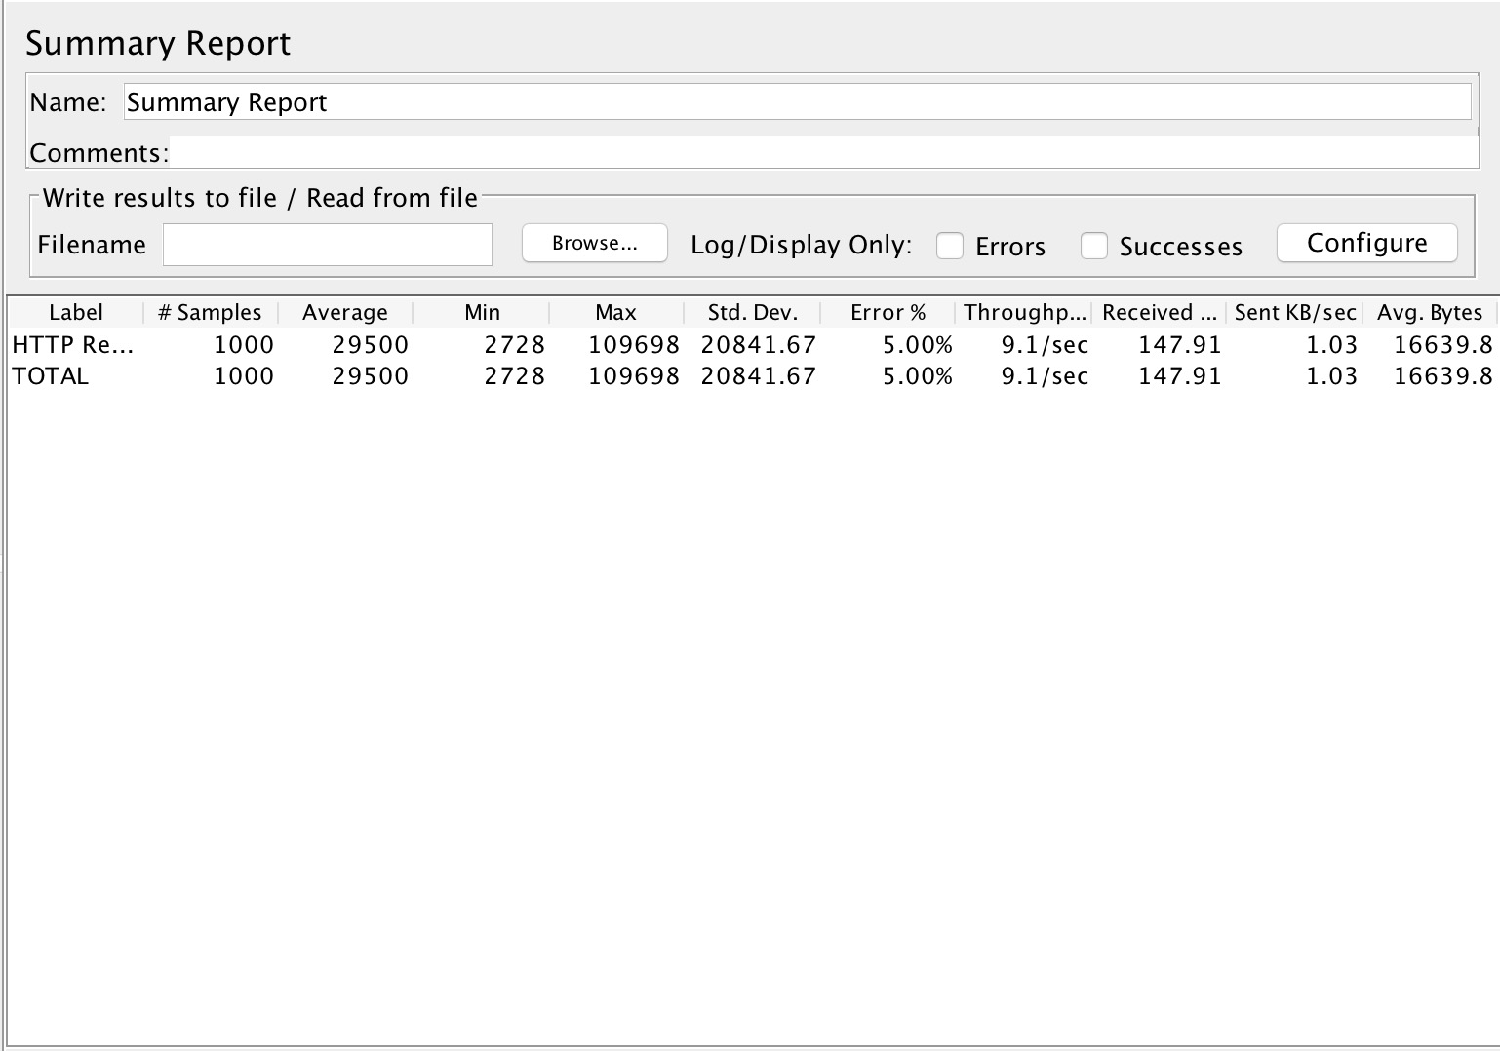

|  |  |  |
| --- | --- | --- |
| Number of Users(threads) | Average response time | Throughput(qps) |
| 50 | 423 | 67.8 |
| 100 | 722 | 84.2 |
| 200 | 1620 | 73.0 |
| 300 | 2003 | 74.1 |
| 500 | 10532 | 23.3 |
| 1000 | 29500 | 9.1 |

We can see the peak throughput happens around 100 threads, the troughput will be around 85qps.

When we used 1000 threads, we got the error(the error rates change to 5%), if we test more threads, the error rates will increase ,which means that this memory size is our server’s bottleneck.

**Test in my local host:**

200 numbers of Users(Thread):

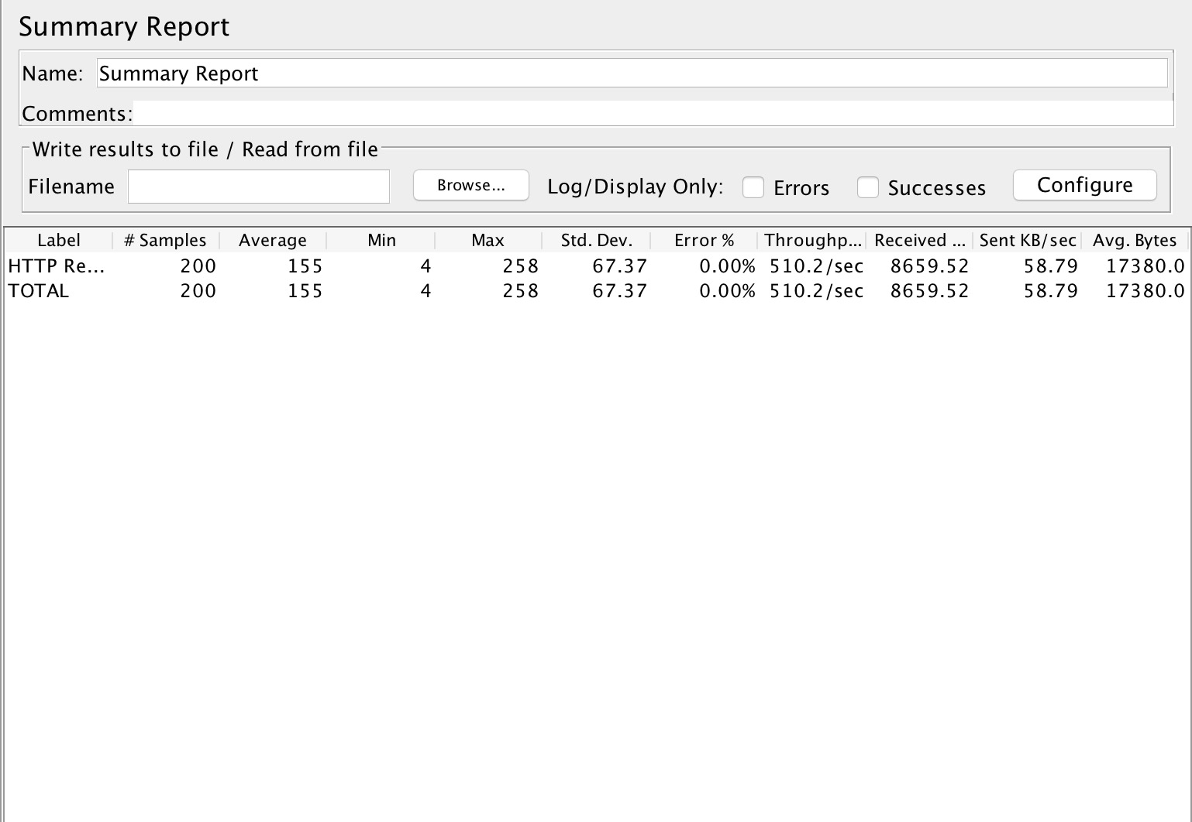

300 numbers of Users(Thread):

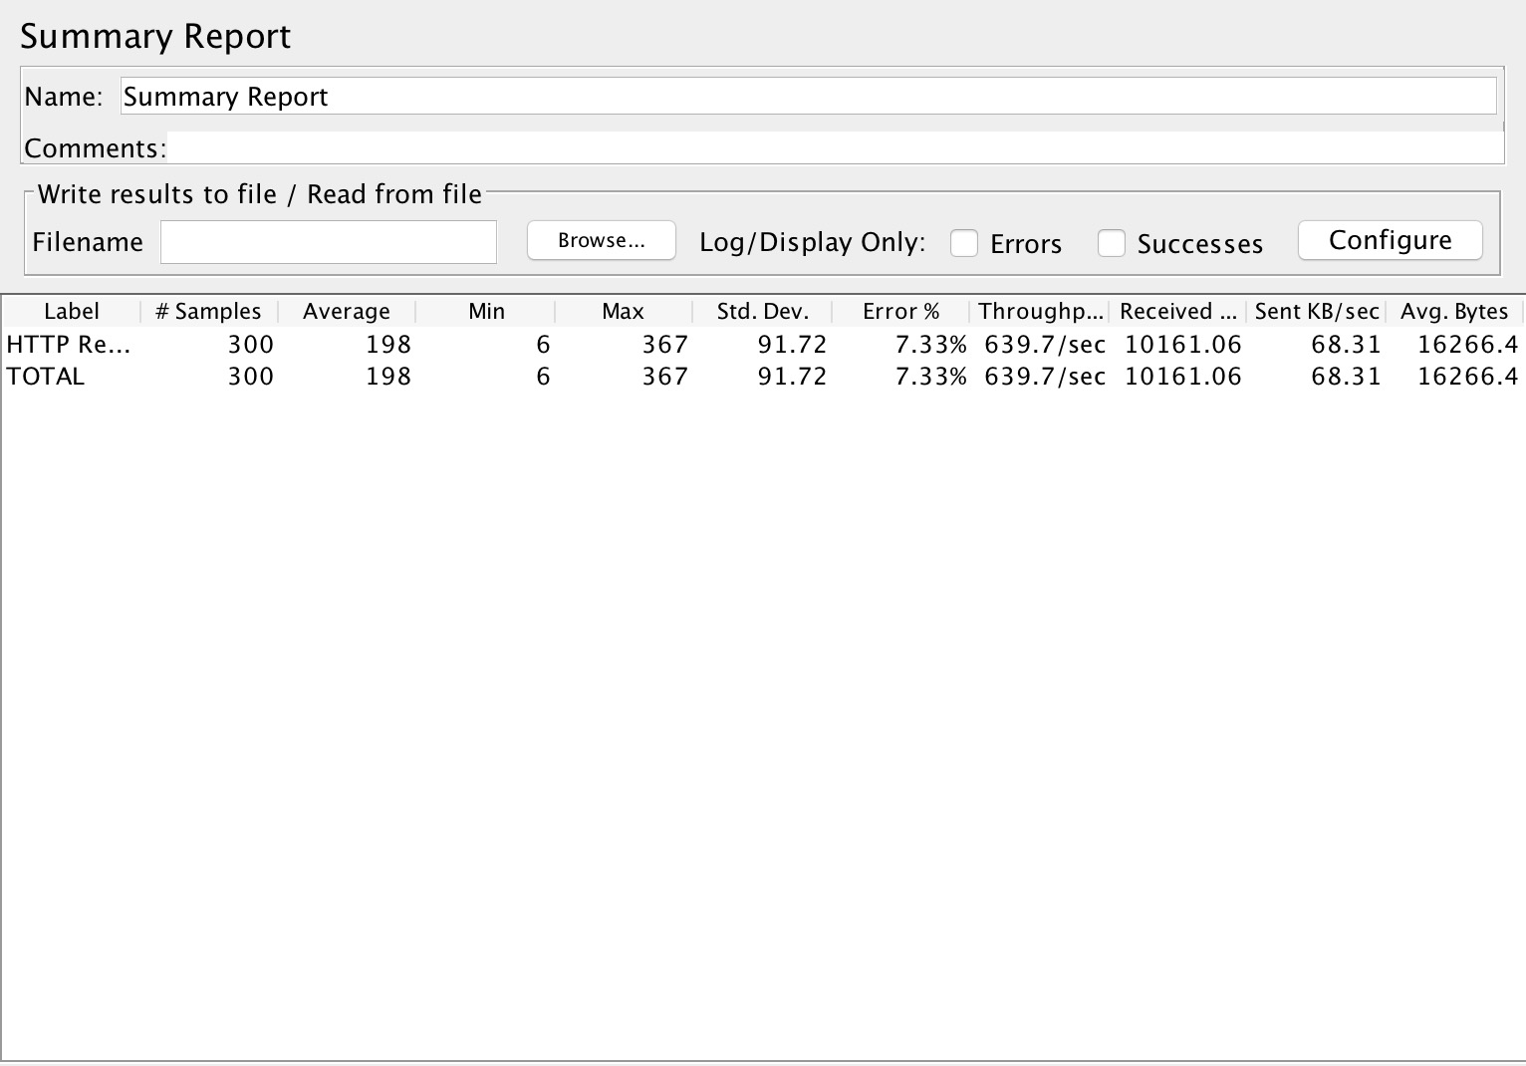

500 numbers of Users(Thread):

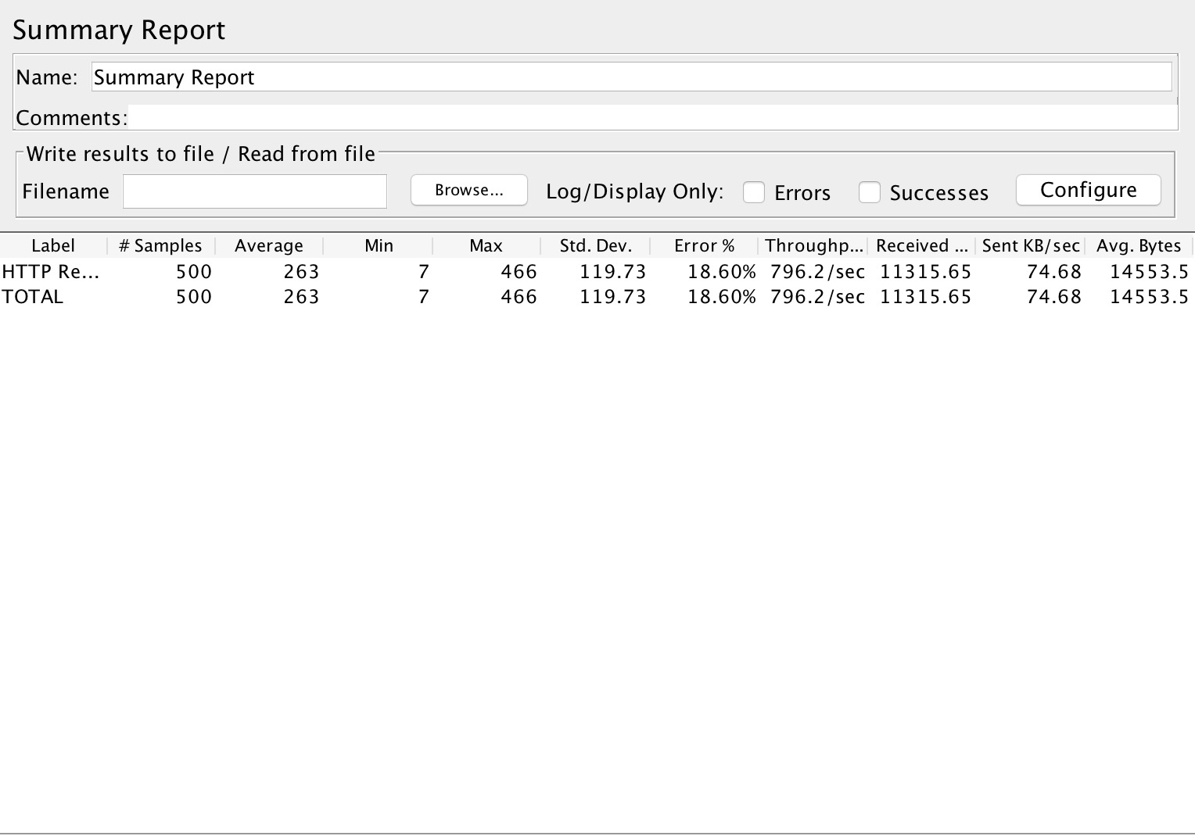

|  |  |  |
| --- | --- | --- |
| Number of Users(threads) | Average response time | Throughput(qps) |
| 200 | 155 | 510.2 |
| 300 | 198 | 639.7 |
| 500 | 263 | 796.2 |

We can see in our local host, the throughput performance is better than cloud service. The peak throughput could reach about 600 qps.

However, the error happens when we got 300 numbers of users, which means that this memory size is our localhost server’s bottleneck.